RUSLE2 (REVISED UNIVERSAL SOIL LOSS EQUATION)
RUSLE2 was developed primarily to guide conservation planning, inventory erosion rates and estimate sediment delivery. Values computed by RUSLE2 are supported by accepted scientific knowledge and technical judgment, are consistent with sound principles of conservation planning, and result in good conservation plans. RUSLE2 has evolved from a series of previous erosion prediction technologies like USLE (Universal Soil Loss Equation) and RUSLE1.

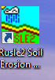
Icon on your computer looks like this.
The opening page looks like this.

This is what the profile page looks like.
- You enter data into this model and it computes sheet and rill erosion
- Enter location of your county
- Enter soil type
- Enter slope percent (%) and length
- Enter crop rotation (management)
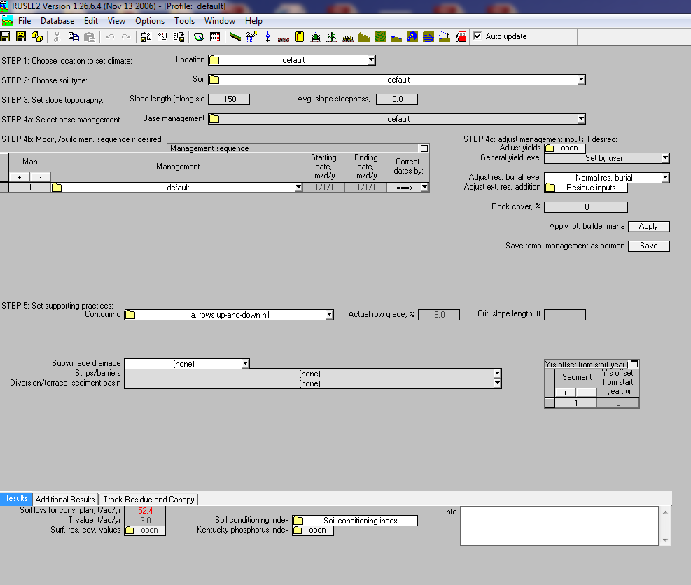
- Enter supporting practices like contouring and terracing

