Sponsors
Regional Grazing School
Sedalia, MO
June 9-11, 2021
8:00 a.m. to 4:00 p.m. each day
Register by Friday, May 28, 2021
Class size limited to 40 participants
University of Missouri Extension
Pettis Soil and Water Conservation District
USDA – Natural Resources Conservation Service

Location
Classroom: Lantern House
21746 West, US-50, Sedalia, MO
Field Activities: 3 locations near Sedalia

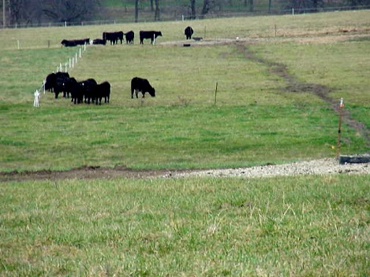
Learn more about:
- Grazing system essentials
- Improving grazing efficiency
- Improving livestock performance
- Reduce stored feed use
- Pasture improvement

___________________________________________________________________

Topics: Presentation Team:
- Grazing system layout and design Amie Breshears
- Grazing arithmetic CES, Ag Business, MU Extension
- Fencing and water development Zach Harding
- Landscape ecology and soil fertility Grazing Technician, Pettis SWCD
- Plant growth, forage characteristics Travis Harper
- Livestock nutrition Agronomy Specialist, MU Extension
- Matching livestock to forage availability John Turner
- Resource evaluation Consultant, MFGC, retired NRCS
- Grazing system economics Mark Kennedy
Consultant, MFGC, retired NRCS
Gene Schmitz
Livestock Specialist, MU Extension

This regional school qualifies participants for cost-share on grazing system practices through the Missouri Soil and Water Conservation program. All sessions are part of the grazing school and must be attended as a whole.

Registration:

Registration, with payment must be received by Friday, May 28, 2021

To register, please provide the information on the form below to Pettis County SWCD

Cost for the three-day school is $150. An additional person from the same operation pays only $55 but only one set of materials is provided to the operation. Registration fee covers catered lunch for 3 days and a complete set of reference materials.

Registration is limited to the first 40 registrants.

For registration information, please contact:
Victoria Kreup at the Pettis Co. SWCD office, Sedalia
victoria.kruep@swcd.mo.gov or 660-827-3339 ext. 3

For program content questions, please contact:
Zach Harding, Zach.Harding@swcd.mo.gov, 660-826-3339 ext. 3
Or
Gene Schmitz, schmitze@missouri.edu, 660-827-0591

-----------------------------------------Clip and return with payment-------------------------------------------

Name___________________________________________________ ____ $150
Phone__________________ Email________________________________
Farm/Ranch Name___________________________ County____________
Address _____________________________________________________
City__________________________ State_____ Zip code______________
Additional person ______________________________________________ $55
Total: $__________

Please enclose check payable to: Pettis County SWCD
Mail to:
Pettis County SWCD, 1407 W. 32nd St., Sedalia, MO 65301

